# ­­my clinic

# Smart Appointment Booking – CRM Project

## Phase 8: Data Management And Deployment

* Goal: To enable streamlined data management and seamless deployment processes in Salesforce. This includes efficient data import/export, duplicate management, backup, and structured application changes using tools like Data Loader, Change Sets, and Salesforce DX. Ensuring data integrity, operational continuity, and scalable deployment practices for ongoing enhancements.

### Data Import Wizard

* The appointment records were imported successfully using Salesforce Data Import Wizard.
* The CSV file contained properly formatted columns including Appointment Name, Date (YYYY-MM-DD), Time (HH:MM:SS), Doctor, Patient, Status (Pending/Confirmed/Cancelled/Completed), and Patient Email.This process allowed bulk creation of appointment records in Salesforce with accurate mapping of all key fields.
* The import results were verified by checking the newly created appointment records in Salesforce UI.Subsequent data imports can follow the same CSV format and process.

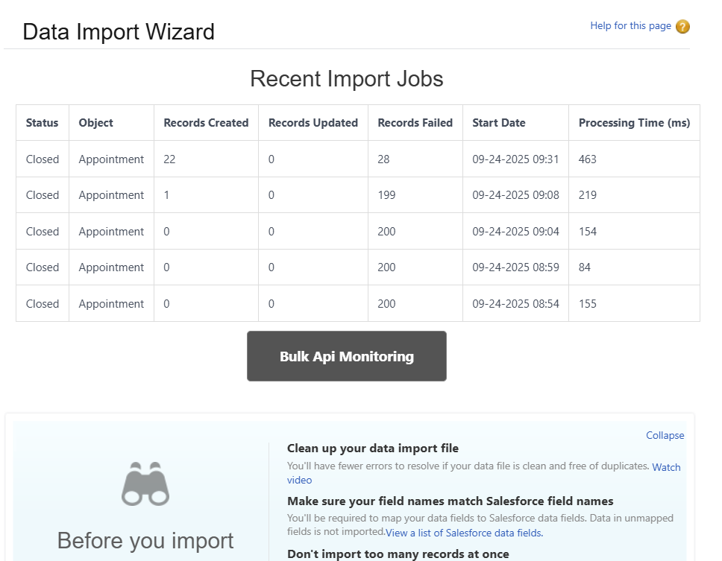

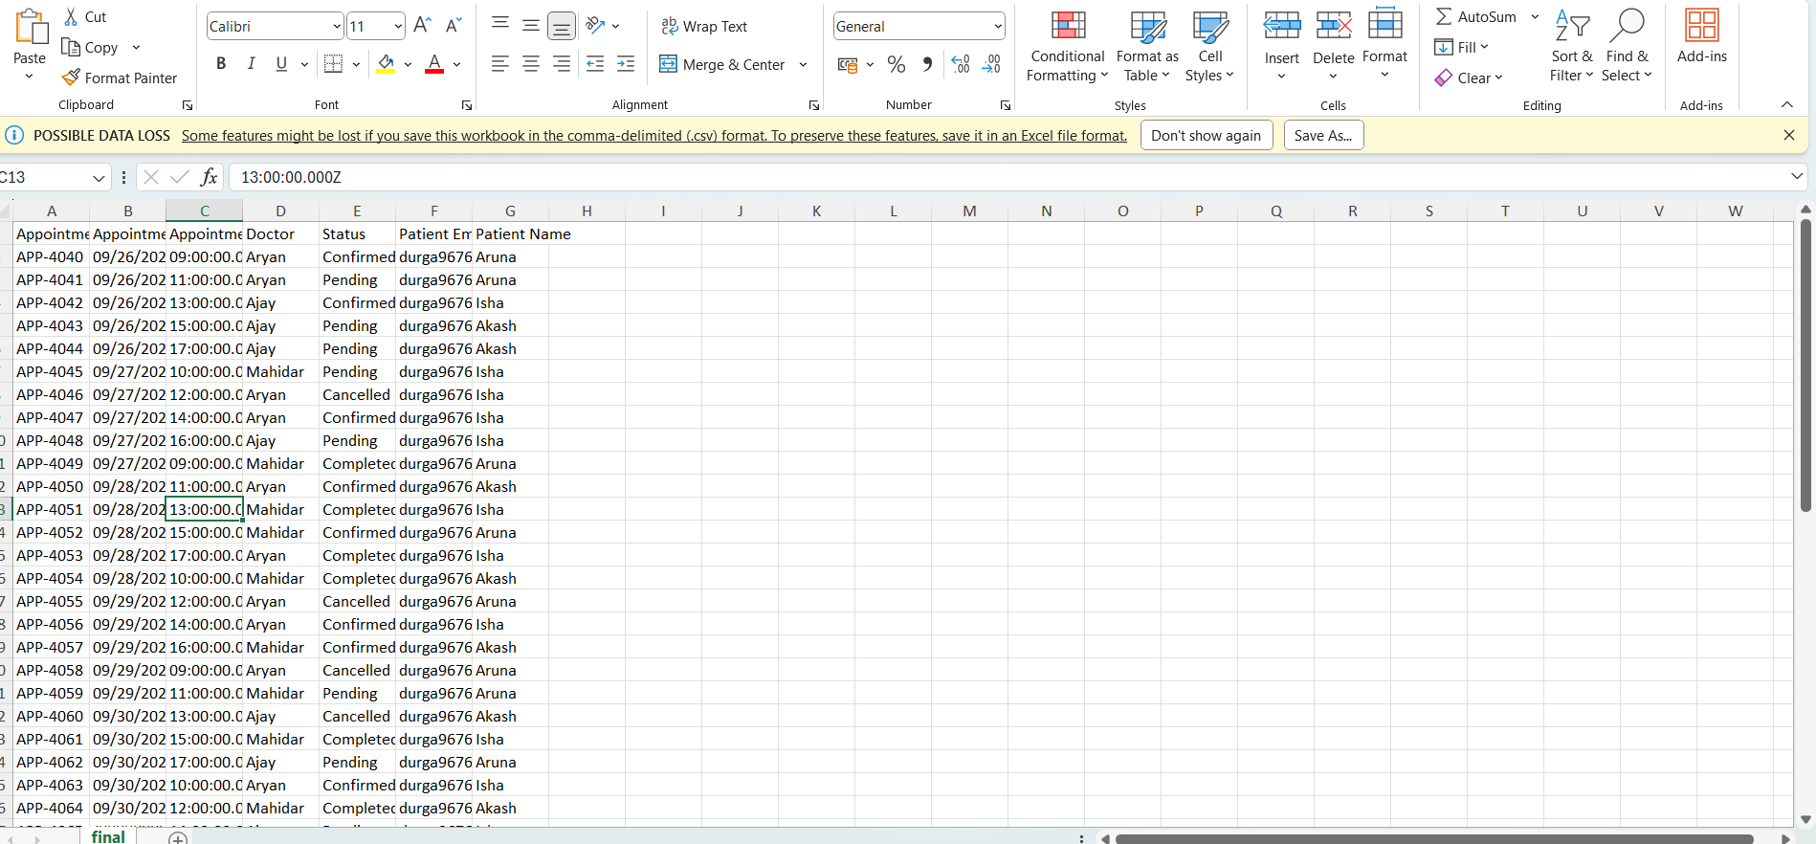

### 2.Data Loader

* For our clinic project, we chose to use the Data Import Wizard for importing appointment records rather than Data Loader.
* The Data Import Wizard fulfilled our bulk data import needs effectively with an easy-to-use, browser-based interface.
* This approach simplified the import process and reduced the need for additional tools or installations.

### 3.Dupilicate Rules

* A custom Appointment Duplicate Rule was configured to prevent the creation of duplicate appointment records in Salesforce
* This rule leverages the "Patient Duplicate Rule matching rule" to identify duplicates based on patient email or other defined criteria.
* By enforcing this duplicate check at data entry, the system maintains clean, accurate appointment records and avoids confusion from redundant bookings.

### 4. Data Export & Backup

* A monthly export was created in Salesforce to back up all data.
* The export produces a downloadable ZIP file with all key records in CSV format.
* This helps ensure data safety and easy recovery when needed.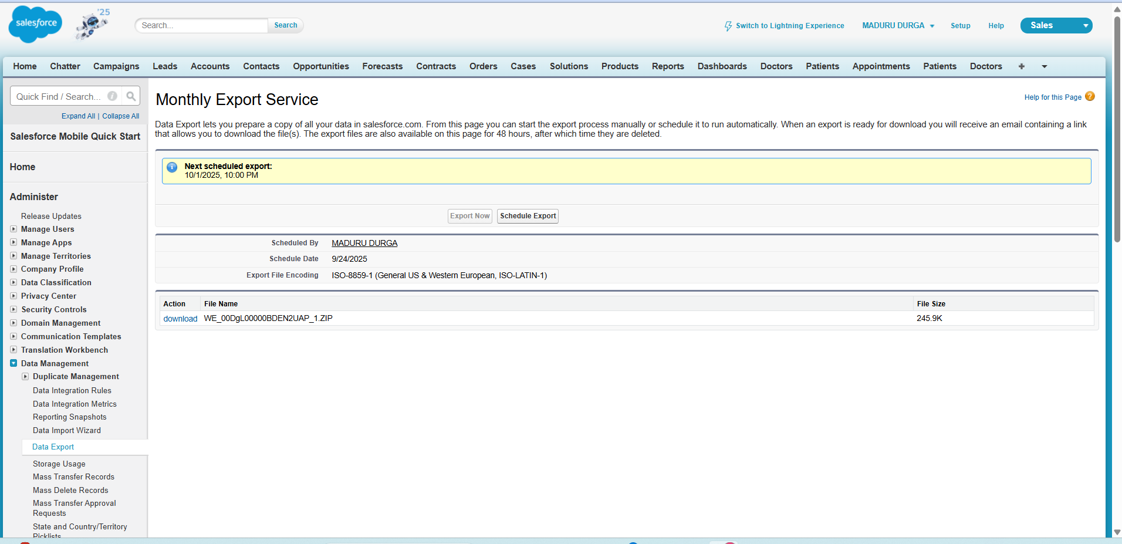

### 5. Change Sets

* Change Sets are used in Salesforce to migrate metadata (like objects, fields, and code) between related orgs, such as sandbox and production.
* Change Sets are not available in Developer Edition orgs, so they cannot be used there

### 6. Unmanaged Vs Managed Packages

* In the MyClinic project, we created an Unmanaged Package that contains all our custom components, including:
* Custom Objects (Appointments, Doctors, Patients)
* Apex Triggers & Handlers
* Flows and Approval Processes
* Lightning Pages and Tabs
* This allows us to bundle and move all clinic-related features together, while keeping them editable for future enhancements.

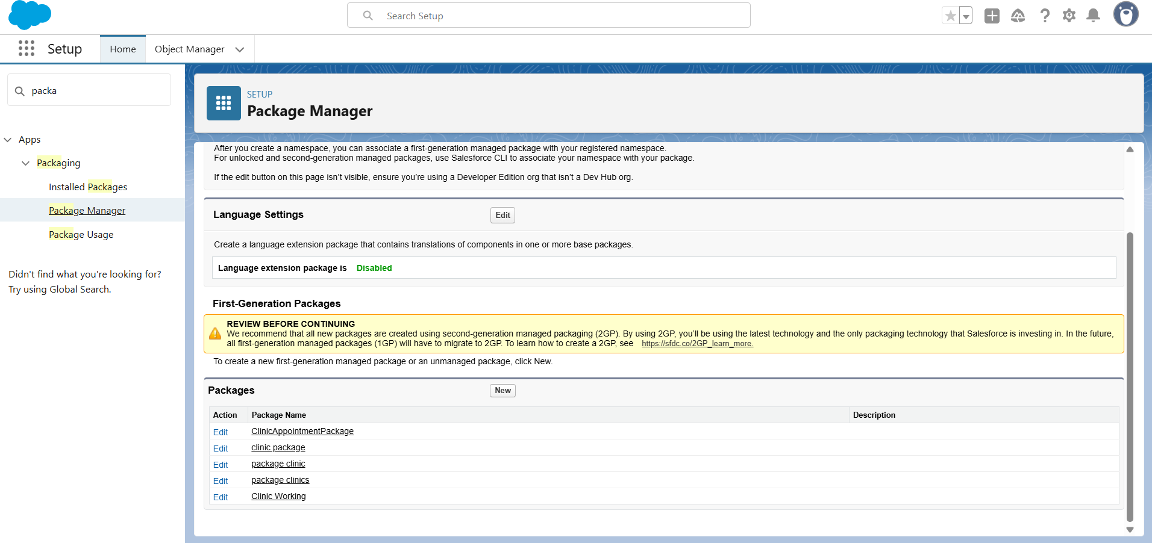

### 7. ANT Migration Tool

* We implemented the ANT Migration Tool to deploy MyClinic project metadata between orgs.
* A package.xml and build.xml were created to retrieve and deploy objects, triggers, and flows.
* This ensured smooth migration of Appointments, Doctors, and Patients setup across environments.

### 8. VS Code & SFDX

* Set up a Salesforce DX project in VS Code for MyClinic app.
* Authorized Dev Hub and connected sandbox org using sfdx force:auth:web:login.
* Retrieved custom objects (Appointments, Doctors, Patients) and Apex triggers with sfdx force:source:retrieve.
* Modified components locally and deployed changes back using sfdx force:source:deploy.

